Ambient Air Quality Data of Bengaluru CAAQM Stations For the month of December, 2021
Winter AQI Bulletin
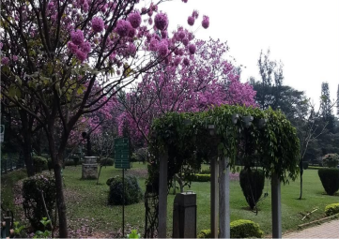

Karnataka State Pollution Control Board
No.49, Parisara Bhavan, Church Street, Bengaluru-560 001.
Website: http://kspcb.karnataka.gov.in
I N D E X
Sl.  No. | Content | Page No.
1 | Introduction | 1
2 | Site of CAAQM Stations operated by KSPCB in Bengaluru | 2
3 | Parameter-wise data tables of CAAQM Stations | 3,4,5,6
4 | Daily AQI values of CAAQMS in Bengaluru-(December-2021) | 7
5 | AQI Trend Bengaluru (December- 2021) | 8
6 | Concentration ranges of Ambient Air Quality Parameters of Bengaluru CAAQM Stations | 9
7 | Air Quality Index | 9
8 | Meteorological parameters, Wind rose diagrams | 9, 10
9 | Broad guidelines for Public | 11
10 | Annexure
 | National Ambient Air Quality Standard (2009)
 | List of Monitoring Stations with parameters

Introduction:
Air pollutants are added in the atmosphere from variety of sources that change the composition of atmosphere and affect the biotic environment. The concentration of air pollutants depend not only on the quantities that are emitted from air pollution sources but also on the ability of the atmosphere to either absorb or disperse these emissions. The air pollution concentration vary spatially and temporarily causing the air pollution pattern to change with different locations and time due to changes in meteorological and topographical condition. The sources of air pollutants include vehicles, industries, domestic sources and natural sources. Because of the presence of high amount of air pollutants in the ambient air, the health of the population and property is getting adversely affected. In order to arrest the deterioration in air quality, Govt. of India has enacted Air (Prevention and Control of Pollution) Act in 1981. The responsibility has been further emphasized under Environment (Protection) Act, 1986. It is necessary to assess the present and anticipated air pollution through continuous air quality survey/monitoring programs. Therefore, Central Pollution Control Board had started National Ambient Air Quality Monitoring (NAAQM) Network during 1984 - 85 at national level. The programme was later renamed as National Air Quality Monitoring Programme (NAMP).
Air pollutants show short term, seasonal and long term variations. Atmospheric conditions determine the fate of the air pollutants after their release into the atmosphere. The mean transport wind velocity, turbulance and mass diffusion are three important and dominant mechanisms in the air pollutant dispersal. Meteorology plays a major role in study of air pollution. The wind speed and direction play a major role in dispersion of air pollutants. The wind direction is the measurement of direction from which the wind is blowing, measured in points of compass viz. North, South, East, West or in Azimuth degrees. Wind direction has an important role in distributing and dispersing pollutants from stationary and mobile sources in horizontally long downwind areas. The wind speed is the measure of horizontal motion of wind relative to the surface of earth per unit time. The effect of wind speed on air pollution is two-fold. It determines the travel time from a source to a given receptor while on the other causes dilution of pollutants in downwind direction. The stronger the wind, the greater will be the dissipation and dilution of pollutants emitted. Hence, the frequency distribution of wind direction as well as wind speed is essential for accurate estimation of the dispersion of pollutants in the atmosphere. The frequency distribution of wind speed and direction varies considerably from month to month.
Bengaluru is known for its cool and pleasant climate, because of its high elevation of around 800-900 meters above sea level. The annual average temperate ranges from 23 to 26 throughout the year. However, in view of rapid urbanization, Industrialisation and increase of vehicles, the air quality is getting disturbed compared to past years. Hence, in order to determine the pollutants, its nature, quality and quantity in the Ambient Air and source of emission generated, the KSPCB has installed 7 CAAQM (Continuous Ambient Air quality monitoring Stations) in Bengaluru and the monitoring is done on 24 hours basis for PM₁₀, PM_{2.5}, SO₂, NO₂, Ammonia, O3, CO and Benzene and the compiled statistical Data is sent to CPCB, New Delhi electronically and also the data is published in the Board Web Site regularly.
1
Further, in order to analyse the trend and concentration of air pollutants in the atmosphere over a period of time and thus enabling the stakeholders to take up mitigative measures, AQI Bulletin serves as a reference guide in understanding the air quality of Bengaluru city in 3 different seasons. The ambient air quality data of Continuous Ambient Air Quality Monitoring Stations (CAAQMS) operated by KSPCB for the period December 01, 2021 to December 31, 2021 are compiled and presented in this report.
Site map of CAAQM stations operated by KSPCB in Bengaluru
CAAQM Stations: Hebbal, Jayanagar, KAVIKA, NIMHANS, Silkboard, Nisarga Bhavan (Basaveshwaranagar), City Railway Station(CRS)
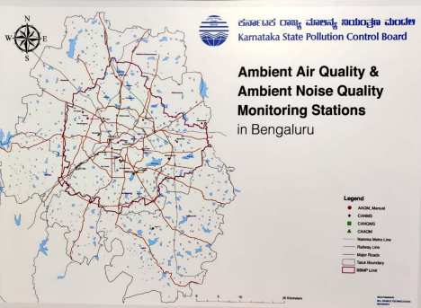
Parameter-wise data tables of CAAQM Stations
I) Hebbal
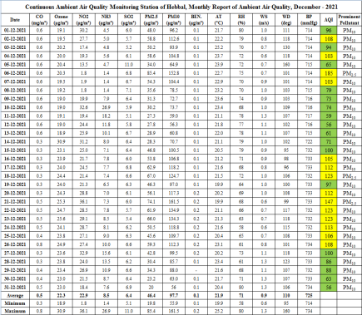
II) Jayanagar
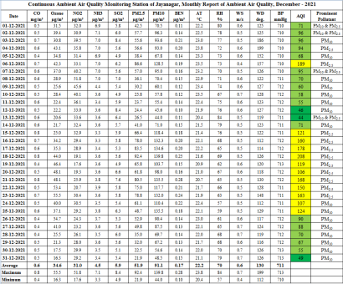

III) KAVIKA, Mysore Road
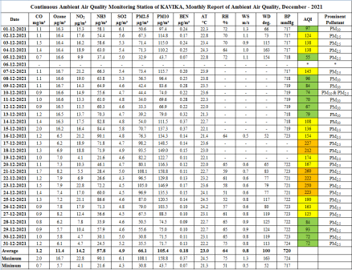IV) NIMHANS
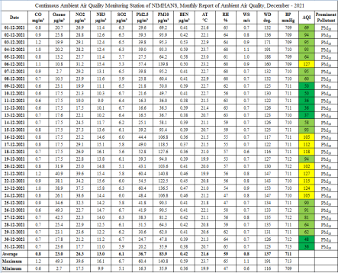
IV) Silk Board
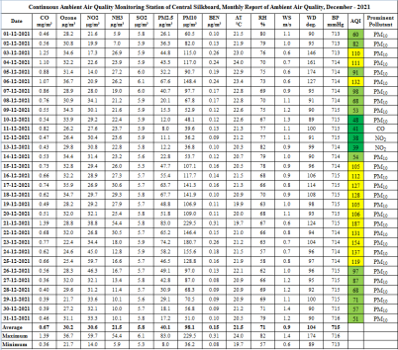VI) Nisarga Bhavan, Basaveshwarnagar,
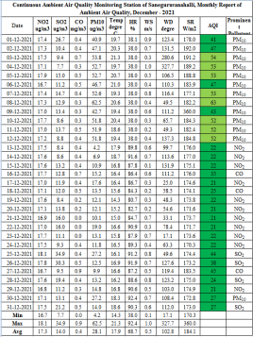
VII) City Railway Station.
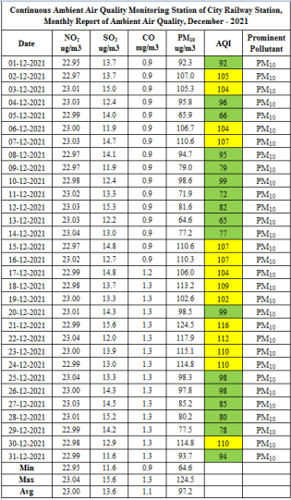
Daily AQI values of CAAQM Stations in Bengaluru during December-2021
AQI Trend in Bengaluru, December 2021
Hebbal, Jayanagar, KAVIKA, NIMHANS, Silkboard, Nisarga Bhavan (Basaveshwaranagar), City Railway Station(CRS)
Data Analysis of Ambient Air Quality:
❖ Particulate Matter (PM₁₀): There is a exceedence in PM₁₀ pollutant in almost all stations except Nisarga Bhavan and that maybe due to high vehicular movement and human activity.(KAVIKA-17 days, Hebbal-15 days, CRS & Silkboard-14 days each, Jayanagara 11 days and NIMHANS-9 days)
❖ Particulate Matter (PM_{2.5}): There is also increase in PM_{2.5} pollutant in the 4 stations monitored with maximum of 17 and 11 days in KAVIKA and Jayanagar and 6 days each at Hebbal and Silk Board. This is attributed due to traffic movement.
❖ Sulphur Dioxide(SO₂): Recorded within permissible limit in all stations across Bengaluru as per NAAQS 2009 standards.
❖ Nitrogen Dioxide(NO₂): Recorded within permissible limit in all stations across Bengaluru as per NAAQS 2009 standards.
❖ Ammonia(NH₃): Observed within permissible limit in all the five monitored stations viz., Hebbal, Jayanagar, KAVIKA, NIMHANS & Silk board as per NAAQS 2009 standards.
❖ Carbon Monoxide(CO): Observed 8-hourly concentration values within the permissible limit in all stations across Bengaluru as per NAAQS 2009 Standard.
❖ Ozone(O₃): Observed within permissible limit in all the five monitored stations viz., Hebbal, Jayanagar, KAVIKA, NIMHANS & Silk board as per NAAQS 2009 standards.
Concentration ranges of Ambient Air Quality Parameters of Bengaluru Stations
The concentration ranges for pollutants of CAAQM stations having 24 hourly standard limits are presented in below table based on detailed tabulated date.
Table-1 Range of 24-hourly Averages for Notified Parameters monitored in December 2021, Bengaluru
Parameters | Hebbal |  | Jayanagar |  | KAVIKA |  | NIMHANS |  | Silk board |  | Nisarga  Bhavan |  | City Railway station
Parameters | MIN | MAX | MIN | MAX | MIN | MAX | MIN | MAX | MIN | MAX | MIN | MAX | MIN | MAX
PM₁₀(µg/m³) | 56 | 162 | 44.0 | 139.8 | 43.7 | 158.8 | 35.9 | 140.8 | 36.2 | 229.5 | 4.2 | 62.5 | 64.6 | 124.5
PM_{2.5}(µg/m³) | 20 | 85 | 21.9 | 92.4 | 30.8 | 108.1 | 16.3 | 60.4 | 8.0 | 83.0 | * | * | * | *
SO₂(µg/m³) | 5.1 | 11.0 | 4.9 | 8.4 | 4.3 | 6.1 | 5.1 | 6.7 | 5.3 | 6.1 | 7.7 | 34.9 | 11.6 | 15.6
NO₂(µg/m³) | 1.8 | 36.1 | 17.6 | 51.8 | 4.1 | 22.8 | 17.5 | 39.6 | 14.0 | 59.7 | 16.7 | 18.1 | 22.95 | 23.04
NH₃(µg/m³) | 26.9 | 1.4 | 3.3 | 7.1 | 21.6 | 90.1 | 9.9 | 16.1 | 5.9 | 34.4 | * | * | * | *
Note: *- Not Monitored
CO, Ozone and Benzene not included as there is no 24 hourly permissible limits in NAAQM

Air Quality Index(AQI)
AQI of Bengaluru was found equally distributed to Good, Satisfactory and Moderate days at all locations of Bengaluru. There is also a slight shift from Moderate to Poor in AQI days at KAVIKA, Mysore Road and this may be due to high vehicular movement in that particular period and construction activity may have also contributed for deteriorating the air quality.
Table-2 AQI Values of CAAQM stations in Bengaluru for the month of December 2021
AQI  Categories | Range | Hebbal | Jayanagar | KAVIKA | NIMHANS | Silkboard | Nisarga Bhavan | City Railway station
Good | (0-50) | - | 3 | 0 | 7 | 4 | 23 | -
Satisfactory | (51-100) | 17 | 16 | 12 | 15 | 13 | 8 | 17
Moderate | (101-200) | 14 | 12 | 12 | 9 | 14 | - | 14
Poor | 201-300 | - | - | 6 | - | - | - | -
Very Poor | 301-400 | - | - | - | - | - | - | -
Severe | (> 401) | - | - | - | - | - | - | -

Meteorological Parameters
Daily average wind speed was observed in the range 0.1 m/s – 1.4 m/s. Monthly average temperature was 21.35˚C with minimum daily average as 17.9˚C and maximum as 23˚C recorded. Monthly average relative humidity was 67.28% with maximum daily average as 92.4 % and minimum as 38% recorded. Low wind speed and calm weather has contributed for the low dispersion of pollutants in the atmosphere resulting in deteriorating AQI during winter season.
Table-3 Monthly Range and Average for Metrological Parameters in Bengaluru, December-2021
Parameters(Unit)* | Average | Maximum | Minimum
Wind Speed(m/s) | 0.75 | 1.4 | 0.1
Temperature(ºC) | 21.35 | 23 | 17.9
Relative Humidity(%) | 67.28 | 92.4 | 38

* Data of 6 Stations
Windrose diagrams: The graphical charts that characterise the speed and direction of wind at the CAAQM Stations.

INFERENCE: The AQI of CAAQMS in Bengaluru ranges from Good to Moderate. It is observed that there is a slight increase in AQI level during winter as compared to previous monsoon months report. The observed AQI reveals that the exceedence is in PM₁₀ and PM_{2.5} pollutants which clearly indicated it might be due to heavy movements of vehicles and also due to environment factor known as Winter inversion effect.
Broad guidelines for Public:
AQI is an initiative intended to enhance public awareness and involvement in efforts to improve air quality. People can contribute by maintaining their vehicles properly (e.g. get PUC checks, replace car air filter, maintain right tyres pressure), following lane discipline & speed limits, avoiding prolong idling and turning off engines at red traffic signals. The following are some of the best practices that are to be followed to maintain/ improve the Air Quality.
1) Avoid using private vehicles viz., cars, bikes and instead use public transports viz., Public Buses and Metro services.
2) Encourage carpool and use smaller vehicles (e.g. avoid SUVs).
3) Construction projects shall compulsorily put up enclosures and barricades around their project and carry out regular water sprinkling to suppress dust. Air purifier can also be installed to mitigate dust pollution.
4) Road dust management by using mechanized road sweeping and water sprinkling system, etc., The Civic Bodies shall regularly remove the silt and muck dumped on the roadside and pavements, besides levelling & Asphalting of Roads and filling up of potholes should be taken up on top priority.
5) Unnecessary parking of vehicles on roadside junctions and circles should be avoided of around 50 to 100 meters.
6) Avoid open burning of garbage wastes, tree leaves, branches, trash, tyres etc., especially near roadsides, lakes & water bodies, open ground, vacant land & Parks.
====********====
NATIONAL AMBIENT AIR QUALITY STANDARDS Concentration in Ambient Air
Sl.
_{No.} Pollutants
Time
Weighted Average
Industrial, Residential Rural and other Areas
Ecologically Sensitive Area (Notified by Central
Government)
Methods of Measurement

1 | Sulphur Dioxide (SO₂) µg/m³ | Annual * | 50 | 20
1 | Sulphur Dioxide (SO₂) µg/m³ | 24  Hours** | 80 | 80
2 | Nitrogen Dioxide (NO₂) µg/m³ | Annual * | 40 | 30
2 | Nitrogen Dioxide (NO₂) µg/m³ | 24  Hours** | 80 | 80
3 | Particulate Mater (Size less than 10 µm) or PM10 µg/m³ | Annual * | 60 | 60
3 | Particulate Mater (Size less than 10 µm) or PM10 µg/m³ | 24  Hours** | 100 | 100
4 | Particulate Mater (Size less than 10 µm) or PM _{2.5} µg/m³ | Annual * | 40 | 40
4 | Particulate Mater (Size less than 10 µm) or PM _{2.5} µg/m³ | 24  Hours** | 60 | 60
5 | Ozone (O₃) µg/m³ | 8 Hours * | 100 | 100
5 | Ozone (O₃) µg/m³ | 1 Hours** | 180 | 180
6 | Lead (Pb) µg/m³ | Annual * | 0.5 | 0.5
6 | Lead (Pb) µg/m³ | 24  Hours** | 1 | 1
7 | Carbon Monoxide (CO) µg/m³ | 8 Hours * | 02 | 02
7 | Carbon Monoxide (CO) µg/m³ | 1 Hours** | 04 | 04
8 | Ammonia (NH₃) µg/m³ | Annual * | 100 | 100
8 | Ammonia (NH₃) µg/m³ | 24  Hours** | 400 | 400
9 | Benzene (C6H6) µg/m³ | Annual * | 05 | 05
10 | Benzo (a) Pyrene (BaP)  µg/m³ | Annual * | 01 | 01
11 | Arsenic (As) µg/m³ | Annual * | 06 | 06
12 | Nickel (Ni) ng/m³ | Annual * | 20 | 20

-Improved west and Gaeke Method – Ultraviolet Fluorescence
-Jacob & Hochheiser Modified (NaOH NaAsO2) Method
-Gas phase Chemiluminescence
-Gravimetric
-TECOM
-Beta attenuation
-Gravimetric
-TECOM
-Beta attenuation
-UV Photometric
-Chemical Method
-AAs/ICP Method after sampling on EPM 2000 or equivalent filter paper -ED-XRF using Teflon filter
-Non dispersive Infrared (NDIR) -Spectroscopy
-Chemiluminescence
-Indophenol Blue Method
-Gas Chromatography (GC) based continuous analyzer
-Adsorption and desorption followed by GC analysis
-Solvent extraction followed by HPLC/GC analysis
-AAS/ICP Method after sampling on EPM 2000 or equivalent filter paper
-AAS/ICP Method after sampling on EPM 2000 or equivalent filter paper
CAAQM STATIONS
Sl.  No. | Stations | Types of activities around location (Residential/ Commercial/  Traffic/Industrial) | Parameters Monitored
1 | Hebbal | Sensitive | SO₂, NO₂, PM₁₀, PM_{2.5}, NH₃, CO, O₃, Benzene& Meteorological parameters
2 | Jayanagar | Commercial | SO₂, NO₂, PM₁₀, PM_{2.5}, NH₃, CO, O₃, Benzene& Meteorological parameters
3 | KAVIKA | Commercial | SO₂, NO₂, PM₁₀, PM_{2.5}, NH₃, CO, O₃, Benzene& Meteorological parameters
4 | NIMHANS | Sensitive | SO₂, NO₂, PM₁₀, PM_{2.5}, NH₃, CO, O₃, Benzene& Meteorological parameters
5 | Silkboard | Residential cum Commercial | SO₂, NO₂, PM₁₀, PM_{2.5}, NH₃, CO, O₃, Benzene& Meteorological parameters
6 | Nisarga  Bhavan | Residential | SO₂, NO₂, PM₁₀, CO
7 | City  Railway  Station | Commercial | SO₂, NO₂, PM₁₀, CO & Meteorological parameters

Plant Trees, Save Environment.

